**USING RAPTOR –SWAP 2 NUMBERS**

**ANIRUDH.R(192011013)**

**FLOWCHART**

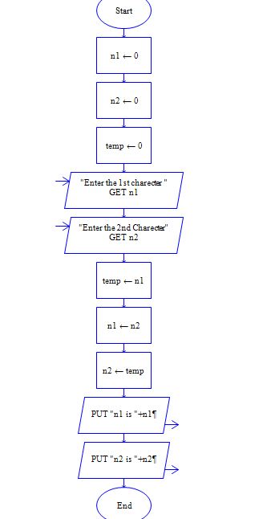

**INPUT**

N1 = 11

N2 = 25

**OUTPUT**

